Contextual Number Problems

Problem 1

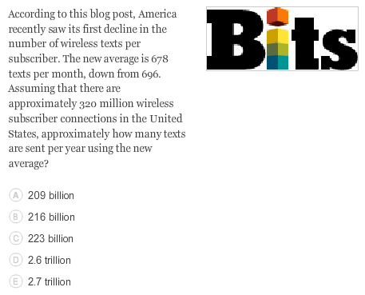

Problem 2

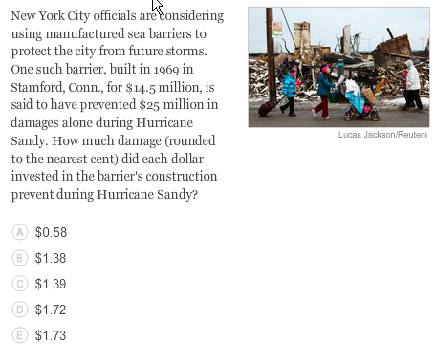

Problem 3

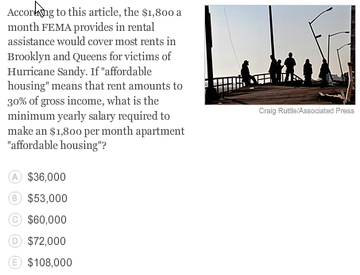

Problem 4

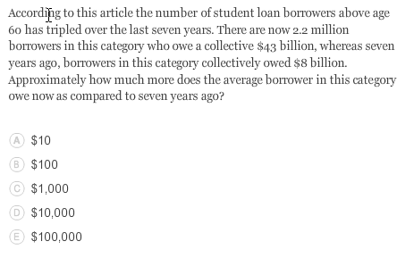

Problem 5

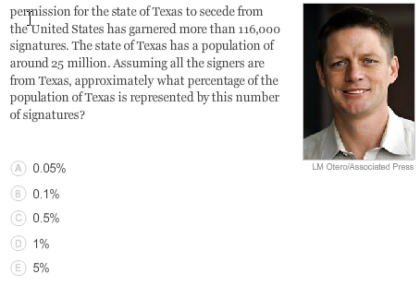

Problem 6

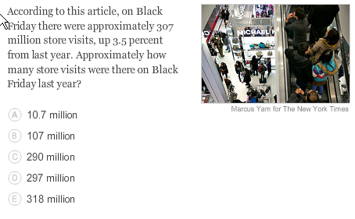

Problem 7



Problem 8

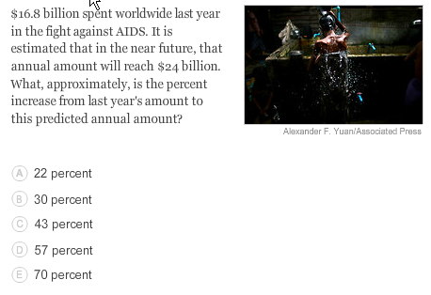

Problem 9

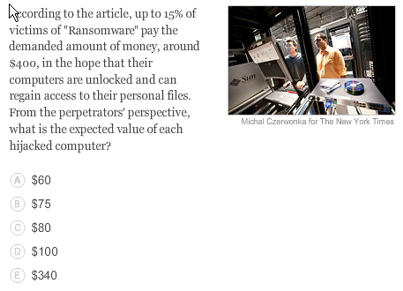

Problem 10

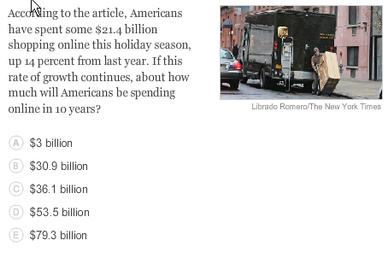

Solutions

Problem 1: At 678 texts per month, 320 million wireless subscribers will send 216,960,000,000 texts per month. Just multiply this number by 12 to get the number per year. 216,960,000,000 X 12 = 2,603,520,000,000 or approximately 2.6 trillion texts per year.

Problem 2: To find the rate of return on the investment, divide the prevented damage total ($25 million) by the total cost ($14.5 million) to find the prevented damage amount per $1 invested. $25 million /$14.5 million is approximately $1.72.

Problem 3: Yearly rent would be $1,800/month X 12 months = $21,600. To find what amount this is 30% of, solve $21,600 = 0.30 X x for x , and get $72,000. Or, notice that $1,800/3 is $600; so if $1,800 is three-tenths of monthly income, then $600 is one-tenth of monthly income, making monthly income $6,000. Multiply by 12 months to get $72,000.

Problem 4: To calculate the average debt of current borrowers, divide the total debt of $43 billion by 2.2 million borrowers to get approximately $19,545. Seven years ago, there were one-third as many borrowers in this category, which is (1/3) X 2.2 million or approximately 733,333 people. So the average debt seven years ago was $8 billion divided by 733,333, or approximately $10,909. The difference in average debt is $19,545 - $10,909 = $8,636, which is closest to $10,000.

Problem 5: Divide 116,000 by 25,000,000 to get 0.0046, or around 0.5%. To approximate, note that 10% of the population of Texas is 2.5 million; thus, 1% is 0.25 million, or 250,000. Half of 250,000, or 125,000, would be around 0.5% or the total population, which is close to the number of signatures.

Problem 6: Increasing a number by 3.5 percent is the same as multiplying it by 1.035. So, if S represents the number of store visits last year, then S multiplied by 1.035 must equal 307 million (the number of store visits this year). Solving for S, we find that S = 307 million/1.035, which is approximately 297 million.

Problem 7: Since the new rate is 70% more than the previous rate, the new rate is equal to the old rate plus 70% of the old rate. Thus, our equation is (Old Rate) X 1.7 = (New Rate). Since the new rate is 15.8%, the old rate is therefore 15.8% / 1.7, which is around 9.29, or 9.3%. To quickly approximate, note that "70% more" than 10% is 10 + 0.70 X 10 = 17%; since this is slightly bigger than 15.8%, the old rate should be a bit less than 10%.

Problem 8: The increase is $24 billion − $16.8 billion which is $7.2 billion. This difference as a percent of the initial figure ($16.8 billion) gives the percent increase, so $7.2 billion / $16.8 billion is approximately 0.43, or a 43 percent increase.

Problem 9: The expected return on each computer hijacked is the product of the chance that the victim pays, which is 15%, times the amount they pay on average ($400), so we have to find 15% of 400. 10% of $400 is $40, so 5% of $400 is $20. Adding these two percentages will equal 15% of $400: $60.

Problem 10: This is an exponential growth situation, with the starting value of $21.4 billion, the rate of growth 14 percent, and the time of growth 10 years. We must calculate ($21.4 billion) X (1.14)10 to get our answer of $79.3 billion.